OT3 Joshua
Dr. Marvin J. Effa
Author: Joshua
Date of writing: 1406 B.C. – 1370 B.C.
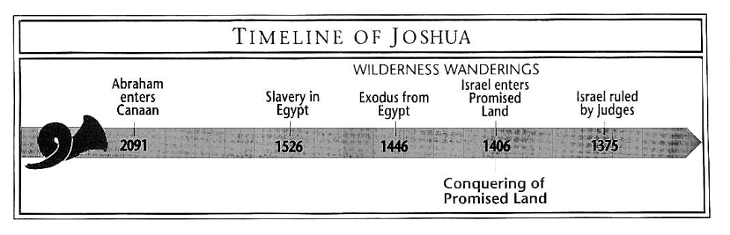
Purpose: To record the conquest of Israel and the division of the land.
Idea: Israel’s military success depends upon God’s favor.

Development:
- Preparation for invasion, Joshua 1-5.
- The battle plans for the land:
  - Central Canaan, Joshua 6-8.
  - Southern Canaan, Joshua 9-10.
  - Northern Canaan, Joshua 11.
- Division of the land, Joshua 13-24.

Key Passage Exegesis:
- Eastern tribes must also fight, Joshua 1:12-18.
- Rahab’s lie rewarded, Joshua 2:3-7.
- A miraculous Jordan River crossing for the new generation, Joshua 3.
- The real captain is always Jesus, Joshua 5:13-15.
- The battle is ultimately a spiritual one, Joshua 6.
- After a victory, beware of defeat, Joshua 7.
- Always check with the Lord: Gibeonites, Joshua 9.
- God can change the course of history, Joshua 10:12-14.

OT3 Judges
Author: Unknown
Date of writing: The date or writing is unknown, but the period of time covered is from 1380 to 1050 B.C.
Purpose: Under Joshua the land was conquered, but strongholds remained throughout the region; each tribe was responsible for destroying peoples God had placed “under the ban.” Judges graphically demonstrates the consequences of disobedience.
Idea: Following one’s own unbiblical thinking is devastating.
Development:
- An overview of the period: some success, but mostly failure, Judges 1:1-3:6.
- Specific judges and oppressing nations, Judges 3:7-16:31.
- Two classic illustrations of syncretic thinking, Judges 17:1-21:25.

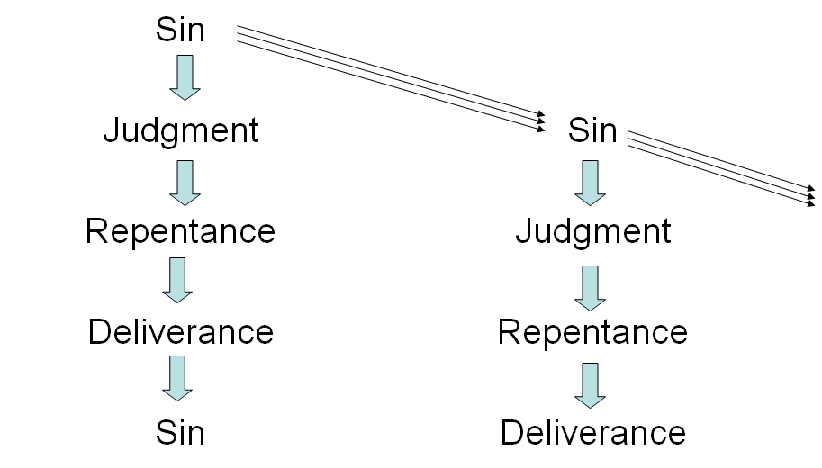

A Suggested Chronology of Oppressing Nations
and Delivering Judges

Oppressor | Dates | Judge | Dates |  | Scripture
Mesopotamia | 1361–1353 | Othniel | 1353–1313 | 40 years | 3:7–11
Moab | 1313–1295 | Ehud | 1295–1215 | 80 years | 3:12–30
Philistia | ? | Shamgar | ? | 10 years | 3:31
Canaan | 1215–1195 | Deborah and Barak | 1195–1155 | 40 years | 4:1–5:31
Midian | 1155–1148 | Gideon  Abimelech | 1148–1108  1108–1105 | 40 years  3 years | 6:1–8:28  9:1–57
Ammon | 1105 | Jephthah | 1105–1099 | 6 years | 10:6–12:7
Philistia | 1099–1059 | Samson | 1085–1065 | 20 years | 13:1–16:31
Key Passage Exegesis:
- Women’s ownership of property, Judges 1:14-15.
- The role of The Angel of the Lord, Judges 2.
- Women in leadership and warfare, Judges 4-5.
- Gideon’s unbelief, Judges 6-8.
- Jephthah’s rash vow, Judges 11:30-31.
- Samson, Judges 14-16.
- False religion, Judges 17-18.
- Perversion, Judges 19-21, Note: Judges 21:25.

OT3 Ruth
Author: Unknown, but some Bible scholars suggest Samuel.
Date of writing: Given the genealogy at the end of the book that includes David as well as certain customs explained by the author, a date at the beginning of David’s reign is possible.
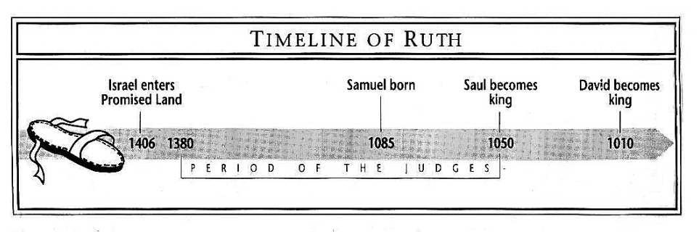
Purpose: To demonstrate that not everyone living during the period of the Judges apostatized.

Idea: Everyone (whether male or female, Jew or gentile, rich or poor) who seeks help from the Lord will receive it.

Development:
- The decline of a Jewish family in Moab, Ruth 1:1-22.
- God’s provision and protection of a destitute, gentile woman, Ruth 2:1-23.
- Ruth’s request for marriage within Israel, Ruth 3:1-18.
- The resolution and celebration of Ruth’s aggressive pursuit of the Lord, Ruth 4:1-17.
- The genealogy of Perez to David, Ruth 4:18-22.

Ryrie, C. C. (1995). Ryrie study Bible: New American Standard Bible, 1995 update (Expanded ed., p. 372). Chicago: Moody Press.

